MONKEY BANANA PROBLEM

AIM: To implement a prolog program for Monkey Banana Problem.

OBJECTIVES:
- To implement the Monkey Banana Problem in Prolog, where a monkey must move a box, climb onto it, and obtain bananas hanging from the ceiling.

ALGORITHM:
- Represent the initial position of the monkey, box, and bananas.
- Allow the monkey to walk to the position of the box.
- Allow the monkey to push/move the box under the bananas.
- Allow the monkey to climb onto the box.
- Allow the monkey to grab the bananas.
- If all conditions are satisfied, the goal is achieved.

SYSTEM-ARCHITECTURE:
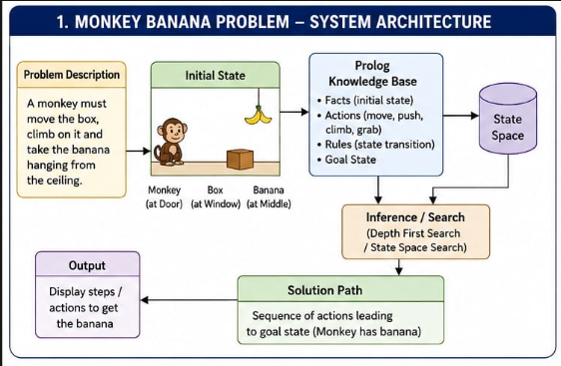

PROGRAM:
% Monkey Banana Problem

% Initial state:
% Monkey is at door, box is at window, bananas are at middle.

state(at(door), at(window), on_floor, has_not_banana).

% Monkey can walk from one place to another
move(state(at(X), Box, Floor, Banana),
state(at(Y), Box, Floor, Banana)) :-
X \= Y.

% Monkey can push the box
move(state(at(X), at(X), on_floor, Banana),
state(at(Y), at(Y), on_floor, Banana)) :-
X \= Y.

% Monkey can climb the box
move(state(at(X), at(X), on_floor, Banana),
state(at(X), at(X), on_box, Banana)).

% Monkey can get bananas
move(state(at(X), at(middle), on_box, has_not_banana),
state(at(X), at(middle), on_box, has_banana)).

% Goal state
goal(state(_, _, _, has_banana)).

% Solve the problem
solve(State, []) :-
goal(State).

solve(State, [Move|Moves]) :-
move(State, NewState),
Move = State -> NewState,
solve(NewState, Moves).

OUTPUT:
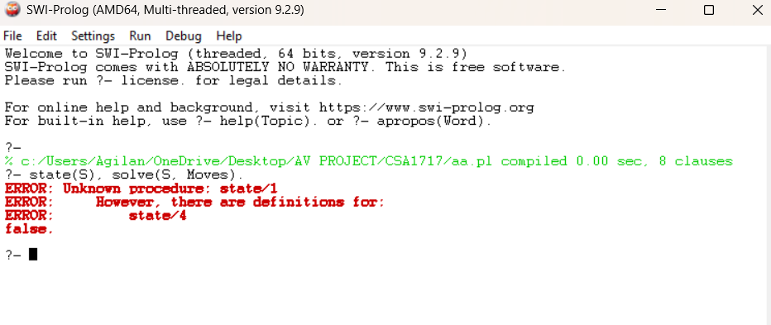

RESULT: Thus the Monkey Banana Problem is implemented successfully using Prolog program.

